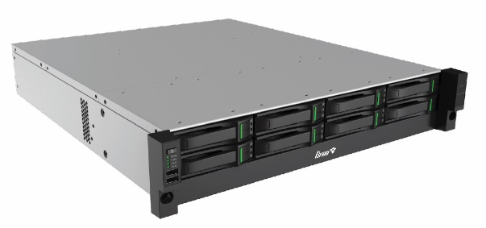
نام محصول : نرم افزار مانیتورینگ مرکزی
نوع محصول : CMS
سازنده : شرکت فناوری نوین مرصاد فاطر
مدل : SR-1000

Feature
• One 4T enterprise-level hard disk is standard equipped  HDMI  • 2 HDMI decoding output  Built-in Software  • Easy7 CMS V9.1.0 |  | System  • Linux  • English WEB management interface  Management Channels  • Max 1000 video channels  Hard Disk  • Support access to 8 hard disks
K1000 | Calculation Rude | Data Classification | Classification
1000 | Uplink Bandwidth | Network Bandwidth | Data Capacity Index
1000 | 1 Point/Server | Point Number
5000 |  | Number of Users
1000 |  | Organizational Area
0.25 | Year | Number of years
1000 |  | Map Punctuation
4 |  | Local Decoding Performance  (output resolution)
180 | 2M/Point | Video Storage Performance
180 | 2M/Point | Video Forwarding Performance
4 | 2M/Point | Client Configuration  i5-9500  16G  Video Preview (decode using CPU)  Google versions below 9.0  support this capability | No Plug-In
 | /1080p/2048/25/H.265
8 | Main code stream/Code rate
 | /720p/2048/25/H.265
10 | Main code stream/Code rate
 | /1080p/2048/25/H.264
16 | Main code stream/Code rate
 | /720p/2048/25/H.264
5 | Main code stream/Code rate
 | /1080p/2048/25/H.265
10 | Main code stream/Code rate
 | /720p/2048/25/H.265
12 | Main code stream/Code rate
 | /1080p/2048/25/H.264
16 | Main code stream/Code rate
 | /720p/2048/25/H.264
16 | Sub stream/Code rate
 | 4CIF/2048/25/H.265
4 | Main code stream/Code rate | Client Configuration  i5-9500  16Gs  Video Playback (decode using CPU) | No Plug-In
 | /1080p/2048/25/H.265
8 | Main code stream/Code rate
 | /720p/2048/25/H.265
10 | Main code stream/Code rate
 | /1080p/2048/25/H.264
16 | Main code stream/Code rate
 | /720p/2048/25/H.264
5 | Main code stream/Code rate
 | /1080p/2048/25/H.265
10 | Main code stream/Code rate
 | /720p/2048/25/H.265
12 | Main code stream/Code rate
 | /1080p/2048/25/H.264
16 | Main code stream/Code rate
 | /720p/2048/25/H.264
16 | Sub stream/Code rate
 | /4CIF/2048/25/H.265
1 | Main code stream/Code rate | Client Configuration  i5-9500  16G  Video Preview  (decode using CPU)  Edge Browser  (version 107) | No Plug-In
 | /1080p/2048/25/H.265
2 | Main code stream/Code rate
 | /720p/2048/25/H.265
4 | Main code stream/Code rate
 | /1080p/2048/25/H.264
7 | Main code stream/Code rate
 | /720p/2048/25/H.264
1 | Main code stream/Code rate
 | /1080p/2048/25/H.265
3 | Main code stream/Code rate
 | /720p/2048/25/H.265
10 | Main code stream/Code rate
 | /1080p/2048/25/H.264
16 | Main code stream/Code rate
 | /720p/2048/25/H.264
5 | Sub stream/Code rate
 | /8MP/2048/25/H.265
1 | Main code stream/Code rate | Client Configuration  i5-9500  16Gs  Video Playback  (decode using CPU)  Edge Browser  (version 107) | No Plug-In
 | /1080p/2048/25/H.265
2 | Main code stream/Code rate
 | /720p/2048/25/H.265
4 | Main code stream/Code rate
 | /1080p/2048/25/H.264
7 | Main code stream/Code rate
 | /720p/2048/25/H.264
1 | Main code stream/Code rate
 | /1080p/2048/25/H.265
3 | Main code stream/Code rate
 | /720p/2048/25/H.265
10 | Main code stream/Code rate
 | /1080p/2048/25/H.264
16 | Main code stream/Code rate
 | /720p/2048/25/H.264
5 | Sub stream/Code rate
 | /4CIF/2048/25/H.265
5 | Concurrent online user | Perform this operation once for  online users 30 to 60s | Pressure Performance Index  (standard value)
40 | Concurrent online user | An average of 45 seconds | Pressure  performance index  (peak value)
15 | Per/s | Number of alerts per second
4 | 200 Users | Number of concurrent  login users per second
15M/s, 25pictures/s |  | Light-weight File Storage | File Storage index
0 |  | Decoding Performance
1.600.000 |  | Total Log Records | Historical Data Capacity Indicator
4.000.000 |  | Total Alarm Records
5.600.000 |  | Data Total | Data Total

